TUTORIAL - CHANGING YOUR PASSWORD

- While logged in, click "change password" in the upper right-hand corner of the screen.
- Type in a new password and confirm it by typing it a second time.
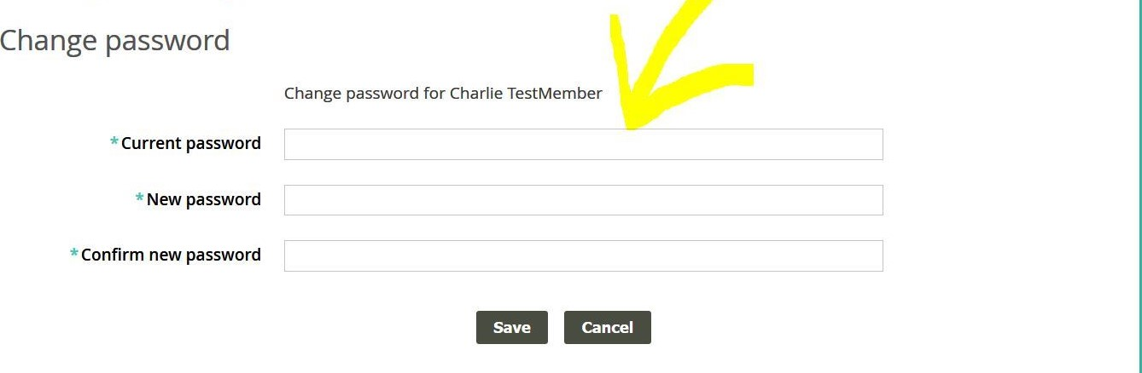
3. Click "SAVE."
If you can't remember your password and are unable to log in to the website, go to the Contact Us page and send an email to the webmaster. The webmaster will send you a temporary password.

