TUTORIAL - CHANGING PRIVACY SETTINGS
You can set your privacy settings any way that you would like. Keep in mind that if you turn off your e-mail, the ONLY e-mails you receive will be system notifications such as membership renewals. You can reset your privacy settings at any time.

- Click on your profile
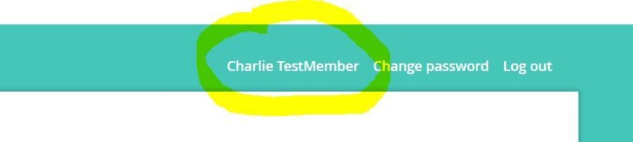
- Click on "Privacy."
- Click "Edit Profile."
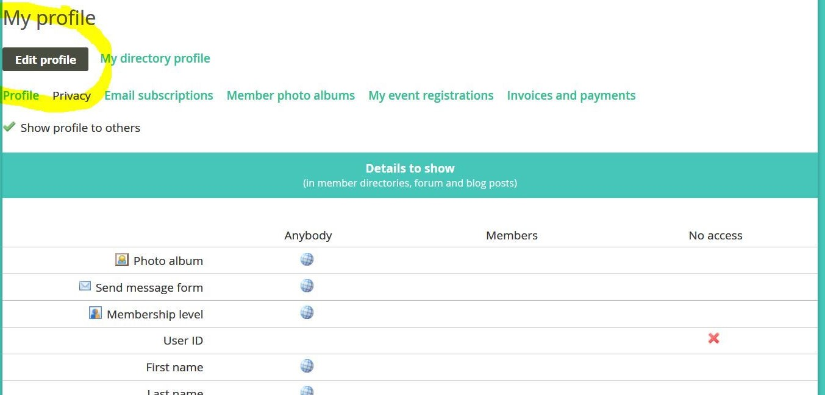

- Select from "Anybody," "Members," or "No Access" for each individual piece of information about yourself.
Then Click Save.
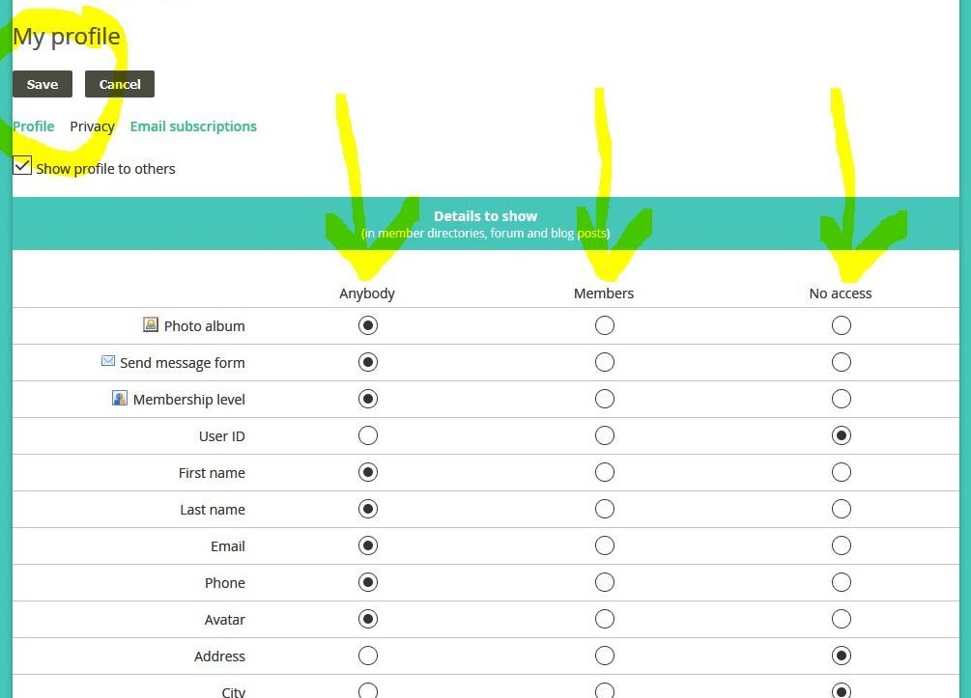

If you can't remember your password and are unable to log in to the website, go to the Contact Us page and send an email to the webmaster. The webmaster will send you a temporary password.

